<https://www.youtube.com/watch?v=hwrnmQumtPw&list=WL&index=6&t=1830s>

I. Intro

1. A shell script contains commands that are executed as if you typed them in the terminal.

2. We'll be using Vim for this tutorial

a. Install Vim : sudo apt-get install vim

b. Vim Commands

1. i : insert mode

2. <ESC> : enter command mode

i. w : Save / Don't Exit

ii. wq : Save / Quit

iii. q! : Quit / Discard Changes

iv. w : Move to front of next word

v. b : Move backwards to front of word

vi. 0 : Move to start of line

vii. $ : Move to end of line

viii. G : Jump to last line

3. Move around with arrows

4. :set number : Displays line numbers

5. :syntax on : Syntax Highlighting

6. :set tabstop=2 : Spaces in tab

7. :set autoindent : Indent new lines

8. Save these in your home/~/.vimrc file

a. Find out what vimrc file you are using with this command in Vim :echo $MYVIMRC

b. NCT - found vimrc file.

Open Terminal

cd

cd /etc/vim/

Now we are at the vimrc file.

I went down to lines:

60 set number

61 syntax on

62 set autoindent

To test it out, I exited back to home, and created a new file:

vim test2

This already had the line numbers displayed so our changes to vimrc worked.

If you want any other permanent file changes for vim, go to that vimrc file.

SC 18:09

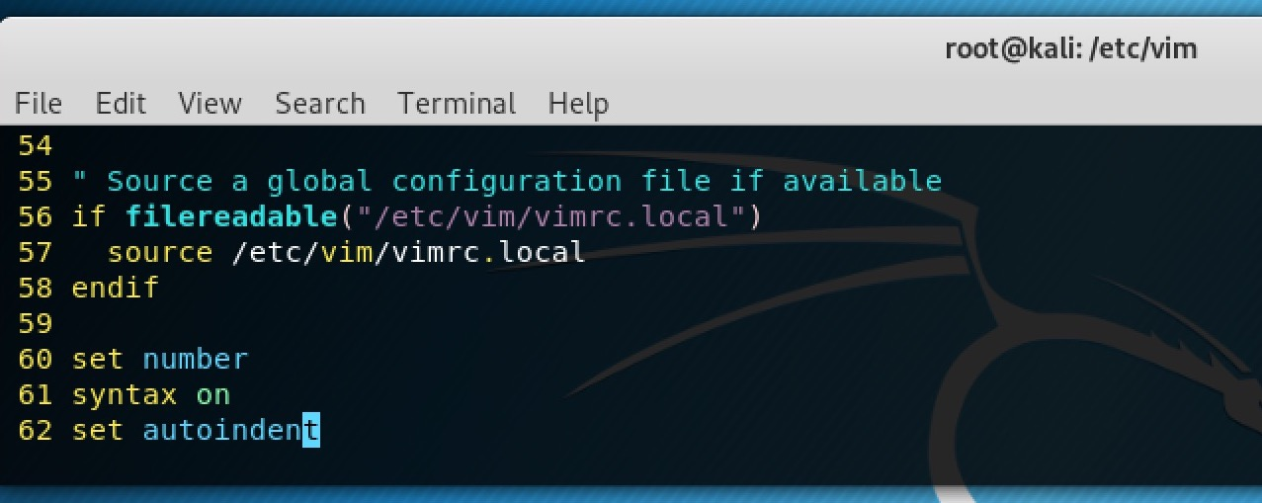

**3. Hello World Script**

# The #! shebang tells the system the interpreter to use for the script

#!/bin/bash

# Comment

echo 'Hello World' # Print the string to the screen

NCT – Terminal 🡪 vim hello_world 🡪 input this

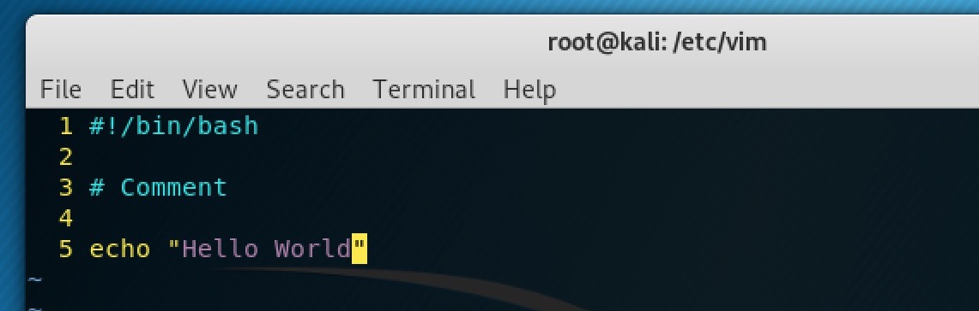

1. Created hello_world with vim. Input seen above.
2. Showed that the hello_world file is now there
3. Tried to run hell0_world, but did not have permission.
4. Chmod 755 so that we have permissions:

7 : Read, Write & Execute

5 : Read & Execute

5 : Read & Execute

1. Then we ran it again, and we clearly echoed “Hello World”

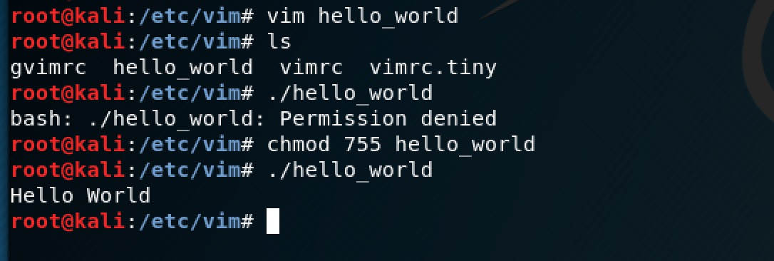

Green hello_world here shows that it is now an executable file?

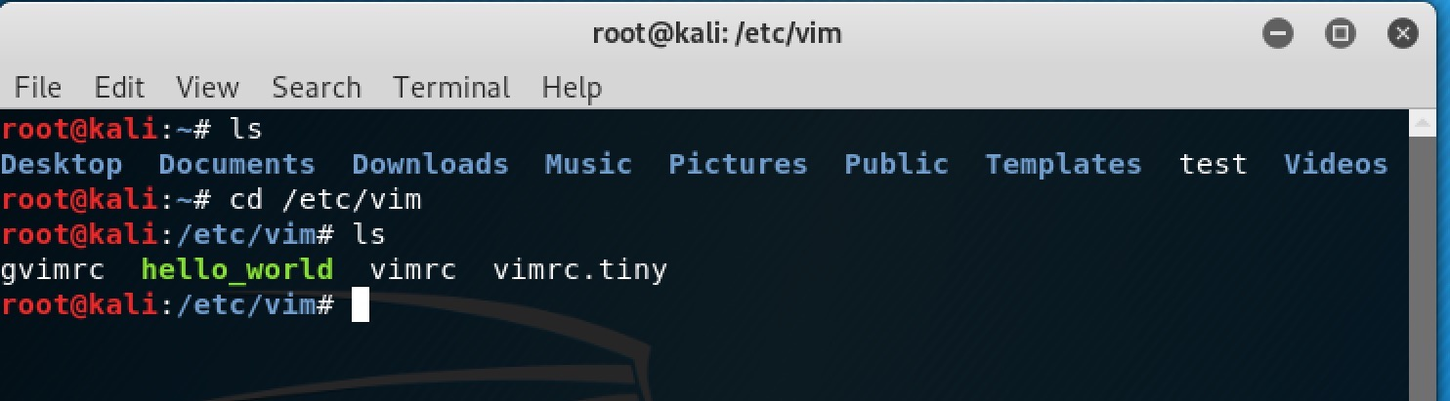

a. To make it executable chmod 755 hello_world

b. Execute with ./hello_world

c. The numbers after chmod define who can do what with the file

d. The numbers represent the Owner, the Group and Everyone else

e. What the numbers mean

1. 7 : Read, Write & Execute

2. 6 : Read & Write

3. 5 : Read & Execute

4. 4 : Read Only

5. 3 : Write & Execute

6. 2 : Write Only

7. 1 : Execute Only

8. 0 : None

**4. We define variables like this myName="Derek"**

a. The variable name starts with a letter or _ and then can also contain numbers

b. The shell treats all variables as strings

c. When declaring a variable you can't have whitespace on either side of the =

d.

#!/bin/bash

declare -r NUM1=5 # Declare a constant

num2=4

# Use arithmetic expansion for adding

num3=$((NUM1+num2))

num4=$((NUM1-num2))

num5=$((NUM1*num2))

num6=$((NUM1/num2))

# Place variables in strings with $

echo "5 + 4 = $num3"

echo "5 - 4 = $num4"

echo "5 * 4 = $num5"

echo "5 / 4 = $num6"

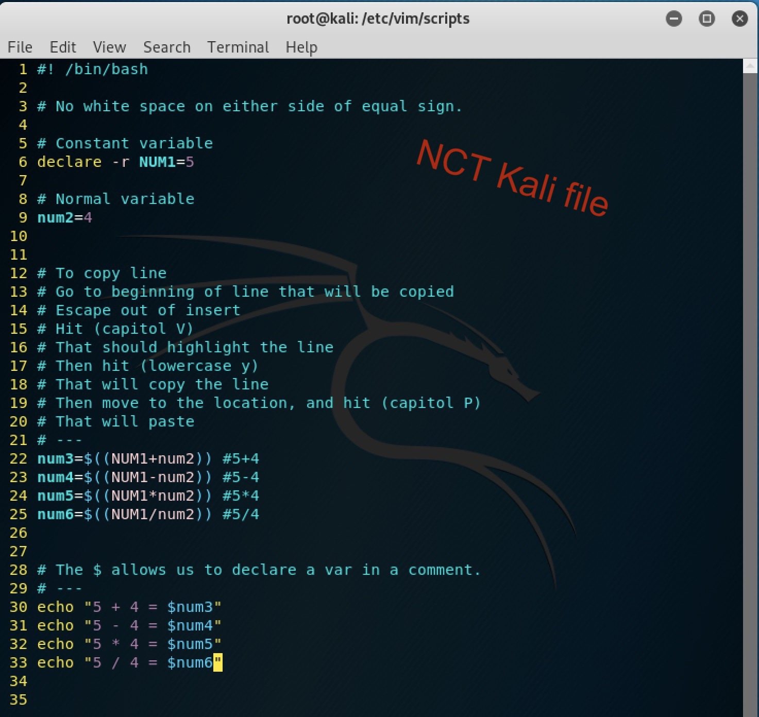

We created, and added to the file.

We chmod 755 to give us the ability to execute the file.

We executed and echoed the results.

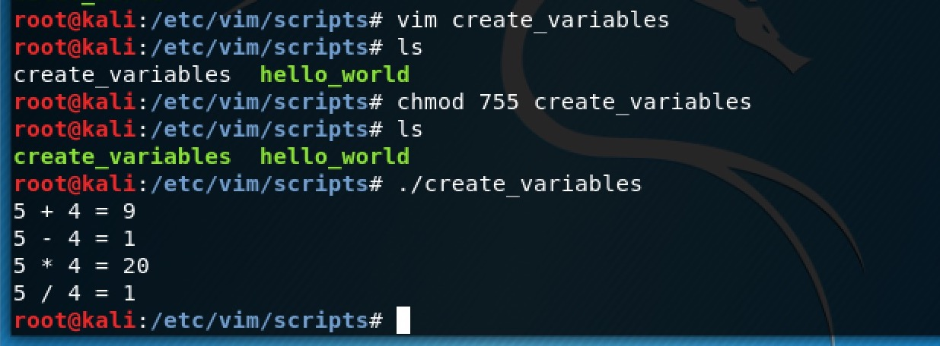

echo $(( 5**2 ))

echo $(( 5%4 ))

# Assignment operators allow for shorthand arithmetic

# +=, -=, *=, /=

rand=5

let rand+=4

echo "$rand"

# Shorthand increment and decrement

echo "rand++ = $(( rand++ ))"

echo "++rand = $(( ++rand ))"

echo "rand-- = $(( rand-- ))"

echo "--rand = $(( --rand ))"

sc 22:18

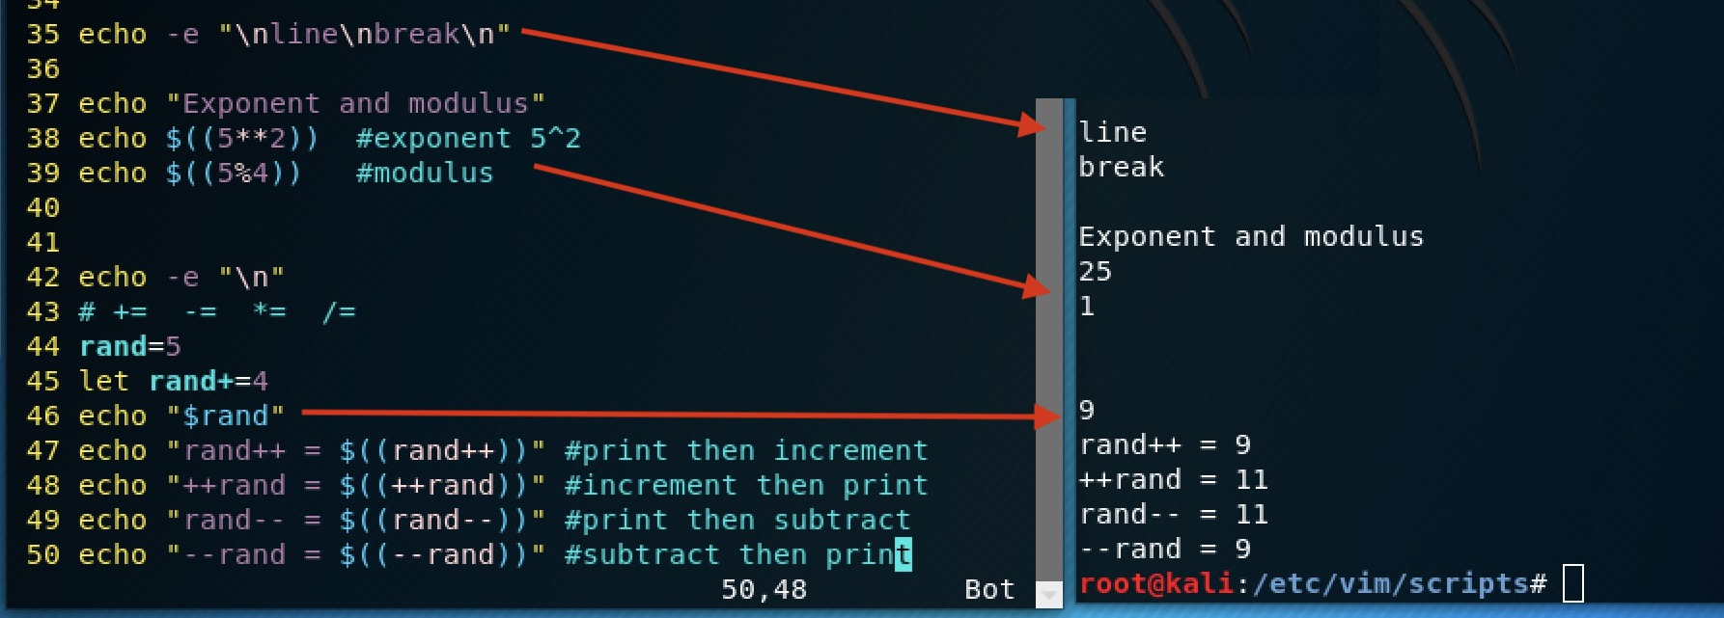

# Use Python to add floats

num7=1.2

num8=3.4

num9=$(python -c "print $num7+$num8")

echo $num9

# You can print over multiple lines with a Here Script

# cat prints a file or any string past to it

cat << END

This text

prints on

many lines

END

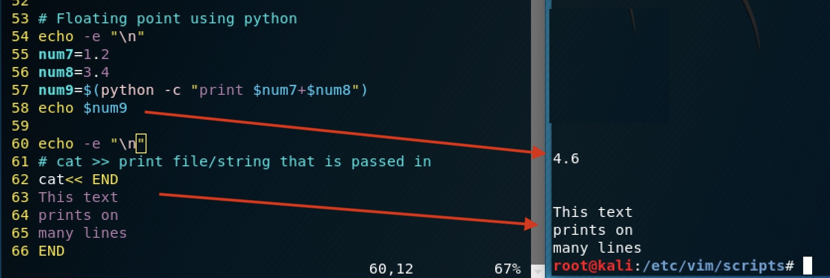

II. Functions

1. You can use functions to avoid the need to write duplicate code

2. Delete all code in Vim with gg then dG

If you copied a file, and you want to delete all the code from the copy.

3. #!/bin/bash

# Define function

getDate() {

# Get current date and time

date

# Return returns an exit status number between 0 - 255

return

}

getDate

sc 22:48

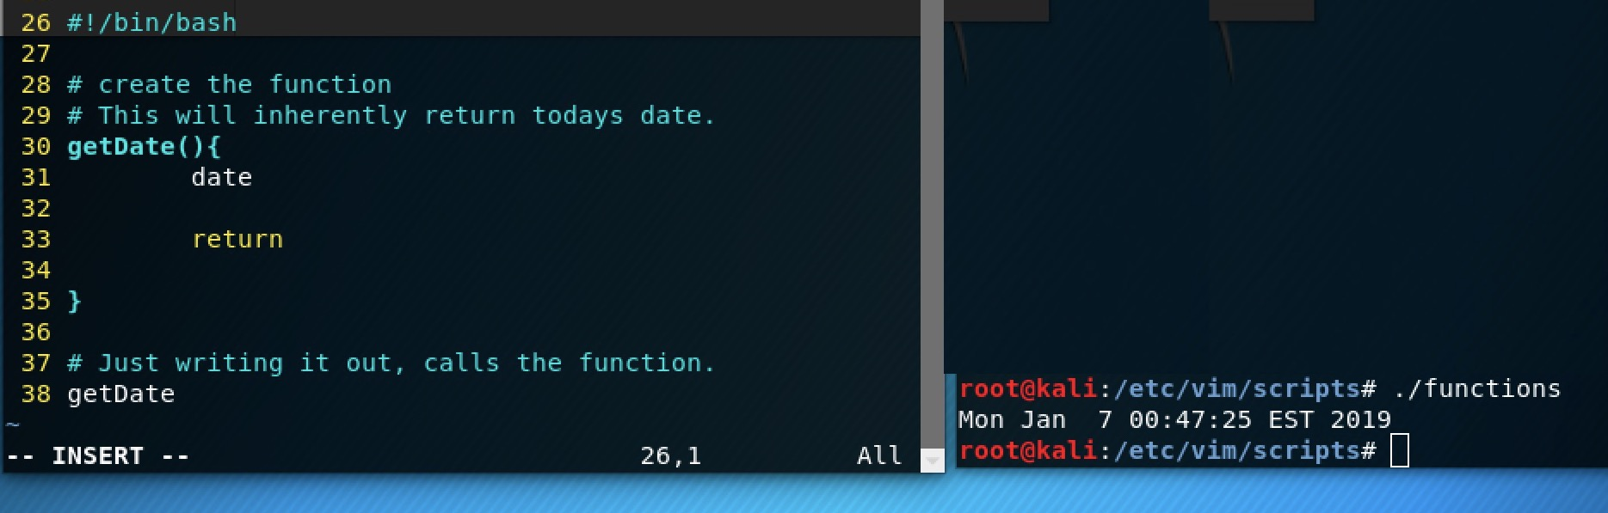

# This is a global variable

name="Derek"

# Local variable values aren't available outside of the function

demLocal() {

local name="Paul"

return

}

demLocal

echo "$name"

sc 22:53

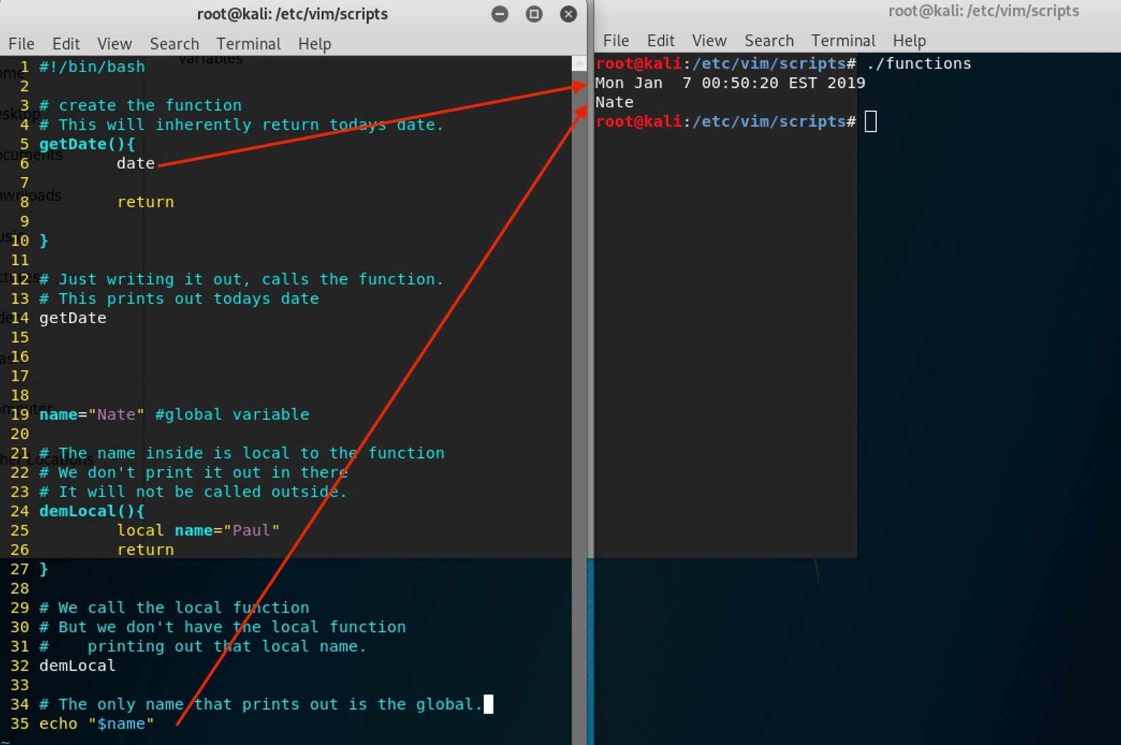

# A function that receives 2 values and prints a sum

getSum() {

# Attributes are retrieved by referring to $1, $2, etc.

local num3=$1

local num4=$2

# Sum values

local sum=$((num3+num4))

# Pass values back with echo

echo $sum

}

num1=5

num2=6

# You pass atributes by separating them with a space

# Surround function call with $() to get the return value

sum=$(getSum num1 num2)

echo "The sum is $sum"

sc 23:00

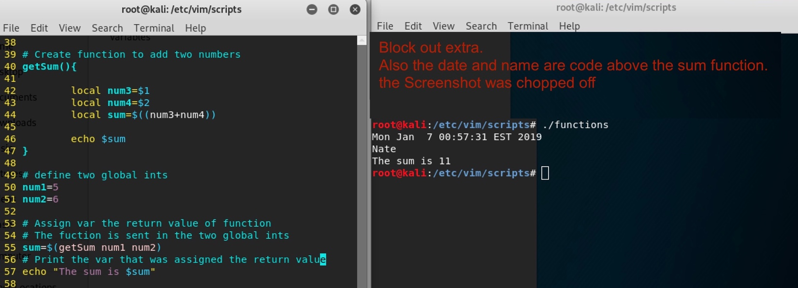

III. Conditionals / Input

1.

#!/bin/bash

# You can use read to receive input which is stored in name

# The p option says that we want to prompt with a string

read -p "What is your name? " name

echo "Hello $name"

sc 23:04

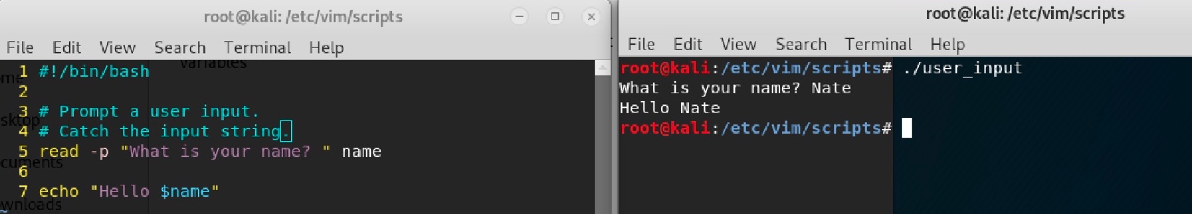

read -p "How old are you? " age

# You place your condition with in []

# Include a space after [ and before ]

# Integer Comparisons: eq, ne, le, lt, ge, gt

if [ $age -ge 16 ]

then

echo "You can drive"

# Check another condition

elif [ $age -eq 15 ]

then

echo "You can drive next year"

# Executed by default

else

echo "You can't drive"

# Closes the if statement

fi

SC 00:09

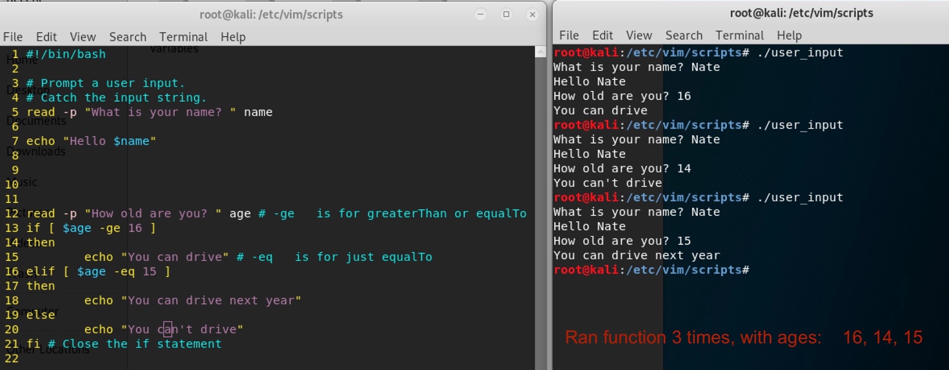

2. Extended integer test

#!/bin/bash

read -p "Enter a number : " num

if ((num == 10)); then

echo "Your number equals 10"

fi

if ((num > 10)); then

echo "It is greater then 10"

else

echo "It is less then 10"

fi

if (( ((num % 2)) == 0 )); then

echo " It is even"

fi

SC 00:19

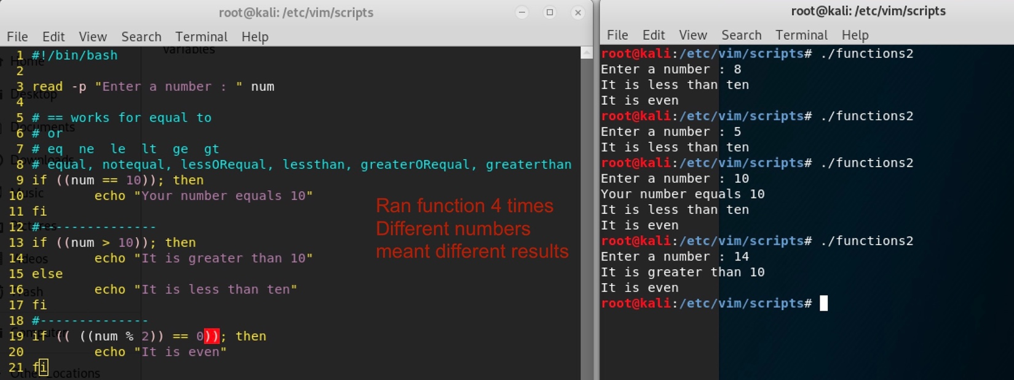

# You can use logical operators like &&, || and !

if (( ((num > 0)) && ((num < 11)) )); then

echo "$num is between 1 and 10"

fi

# && and || can be used as control structures

# Create a file and then if that worked open it in Vim

touch samp_file && vim samp_file

# If samp_dir doesn't exist make it

[ -d samp_dir ] || mkdir samp_dir

# Delete file rm samp_file

# Delete directory rmdir samp_dir

Sc 00:30

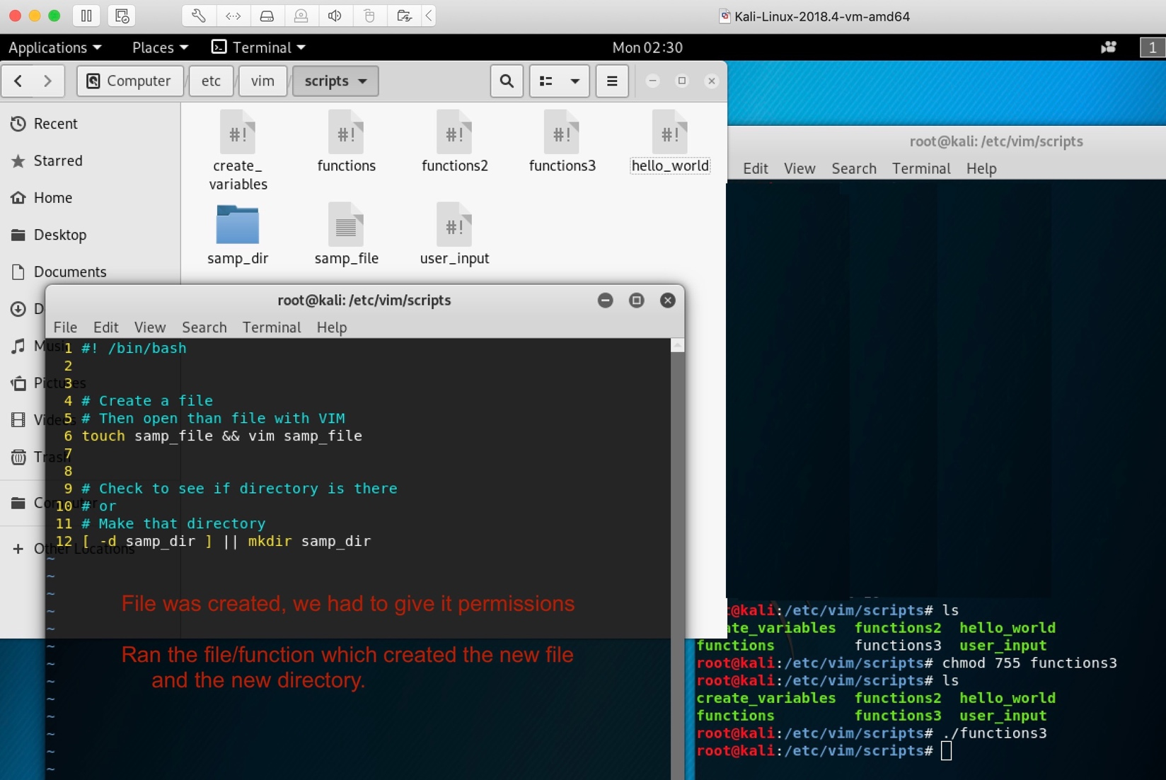

3. Testing strings

#!/bin/bash

str1=""

str2="Sad"

str3="Happy"

# Test if a string is null

if [ "$str1" ]; then

echo "$str1 is not null"

fi

if [ -z "$str1" ]; then

echo "str1 has no value"

fi

# Check for equality

if [ "$str2" == "$str3" ]; then

echo "$str2 equals $str3"

elif [ "$str2" != "$str3" ]; then

echo "$str2 is not equal to $str3"

fi

if [ "$str2" > "$str3" ]; then

echo "$str2 is greater then $str3"

elif [ "$str2" < "$str3" ]; then

echo "$str2 is less then $str3"

fi

sc 0044

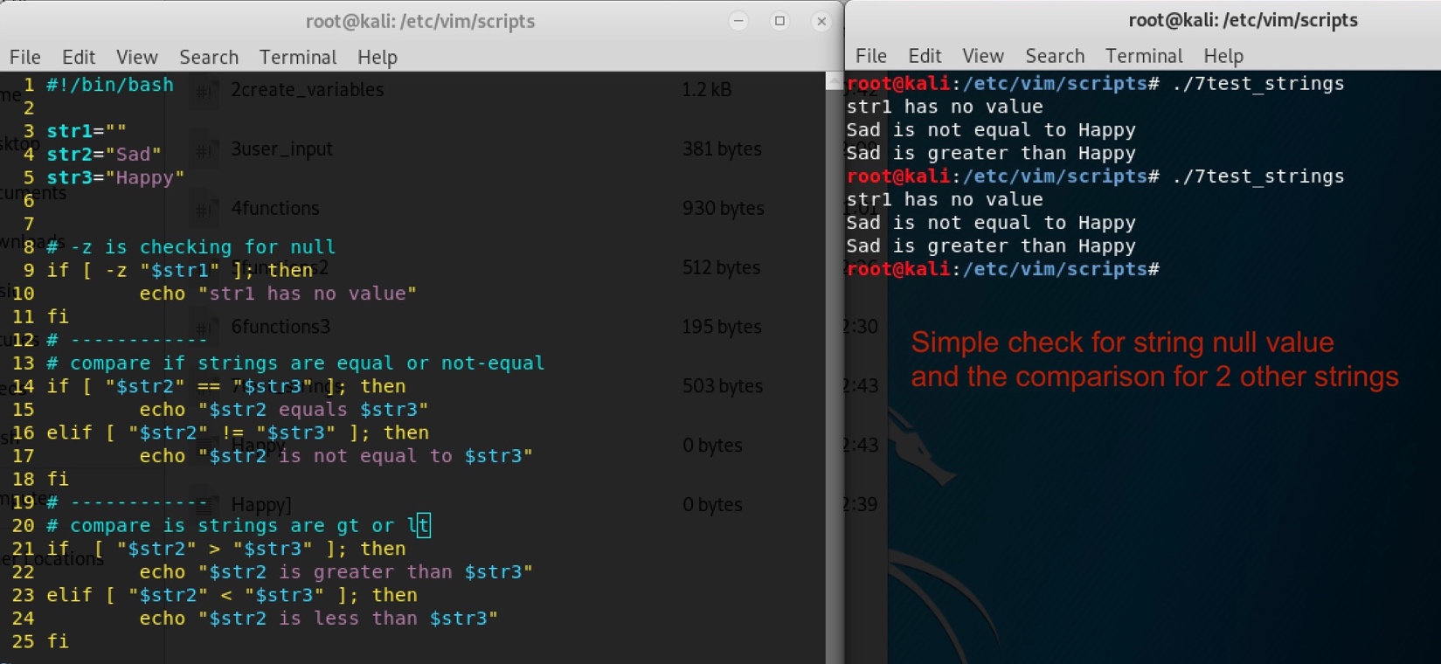

# Check the file test_file1 and test_file2

file1="./test_file1"

file2="./test_file2"

if [ -e "$file1" ]; then

echo "$file1 exists"

SC 00:51

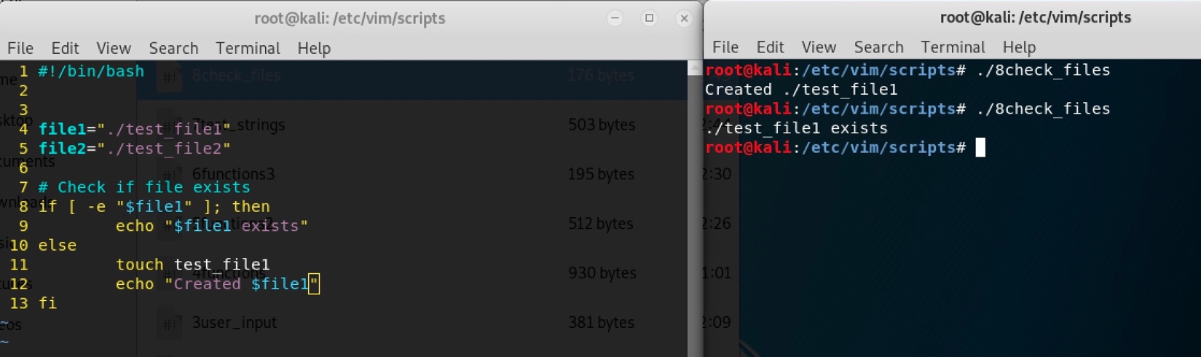

if [ -f "$file1" ]; then

echo "$file1 is a normal file"

fi

if [ -r "$file1" ]; then

echo "$file1 is readable"

fi

if [ -w "$file1" ]; then

echo "$file1 is writable"

fi

if [ -x "$file1" ]; then

echo "$file1 is executable"

fi

if [ -d "$file1" ]; then

echo "$file1 is a directory"

fi

if [ -L "$file1" ]; then

echo "$file1 is a symbolic link"

fi

if [ -p "$file1" ]; then

echo "$file1 is a named pipe"

fi

if [ -S "$file1" ]; then

echo "$file1 is a network socket"

fi

if [ -G "$file1" ]; then

echo "$file1 is owned by the group"

fi

if [ -O "$file1" ]; then

echo "$file1 is owned by the userid"

fi

fi

SC 00:59

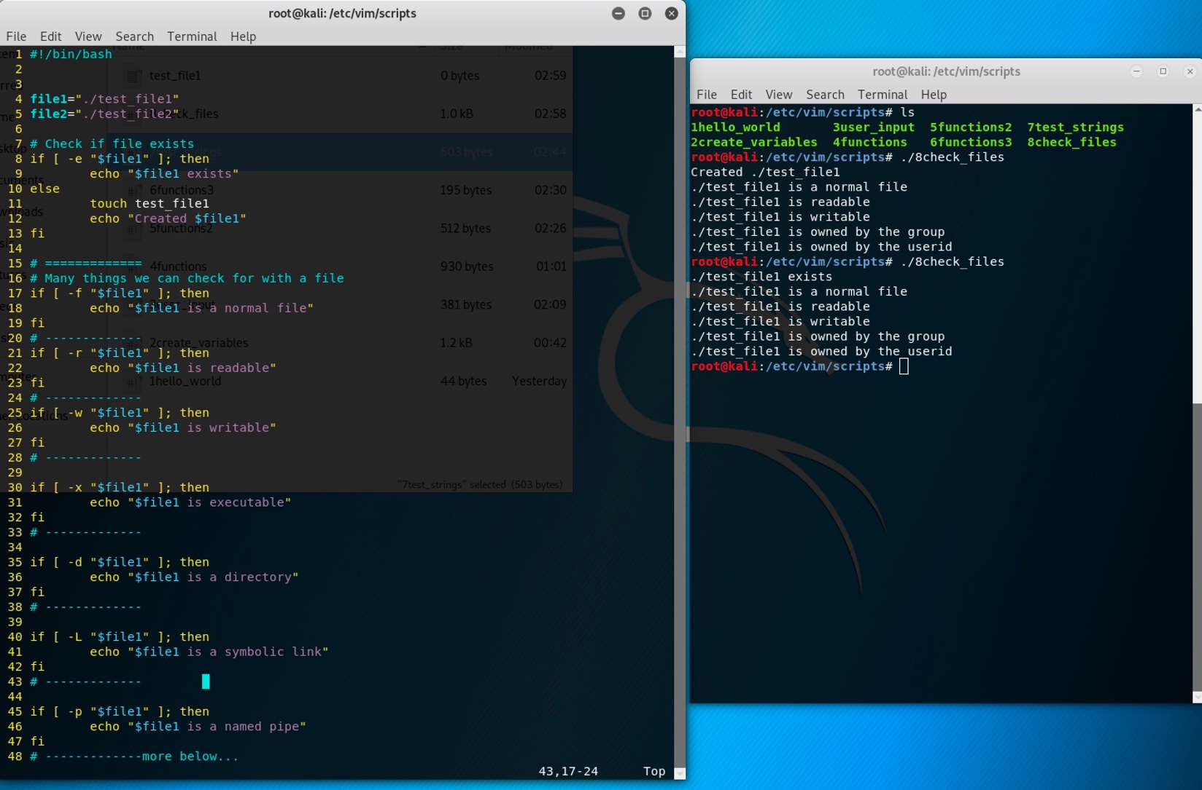

Note: we are at 30:30 in the video

**4. With extended test [[ ]] you can use Regular Expressions**

#!/bin/bash

#pat="^[0-9]{8}$"

#enter group of numbers between 0-9, and enter at least 8

read -p "Validate Date : " date #read info from user

pat="^[0-9]{8}$" #create a patttern

if [[ $date =~ $pat ]]; then

echo "$date is valid"

else

echo "$date is not valid"

fi

SC 15:27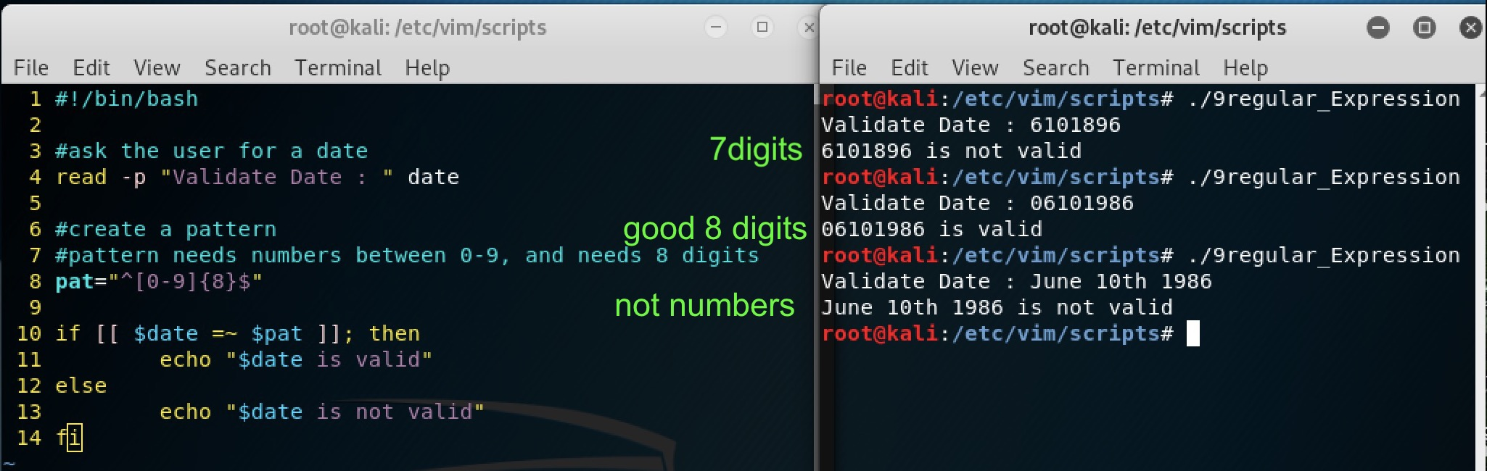

5. # Read multiple values

#!/bin/bash

read -p "Enter 2 Numbers to Sum : " num1 num2

sum=$((num1+num2))

echo "$num1 + $num2 = $sum"

# Hide the input with the s code

read -sp "Enter the Secret Code" secret

if [ "$secret" == "password" ]; then

echo "Enter"

else

echo "Wrong Password"

fi

sc 15:38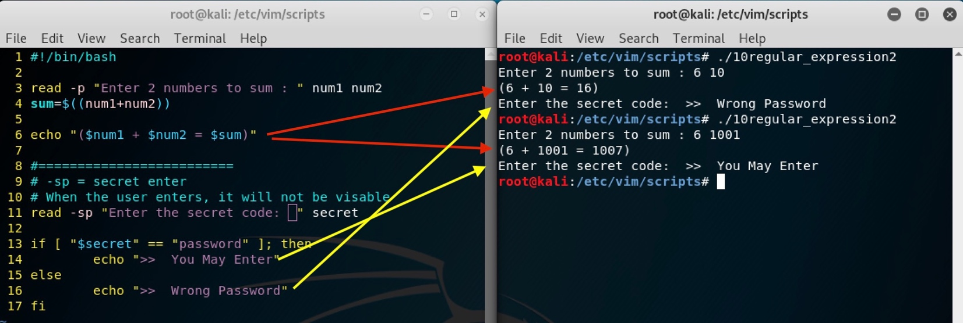

6. You can set what separates the values with IFS

#!/bin/bash

# Store the original value of IFS

OIFS="$IFS"

# Set what separates the input values

IFS=","

read -p "Enter 2 numbers to add separated by a comma" num1 num2

# Use the parameter expansion ${} to substitute any whitespace

# with nothing

num1=${num1//[[:blank:]]/}

num2=${num2//[[:blank:]]/}

sum=$((num1+num2))

echo "$num1 + $num2 = $sum"

# Reset IFS to the original value

IFS="$OIFS"

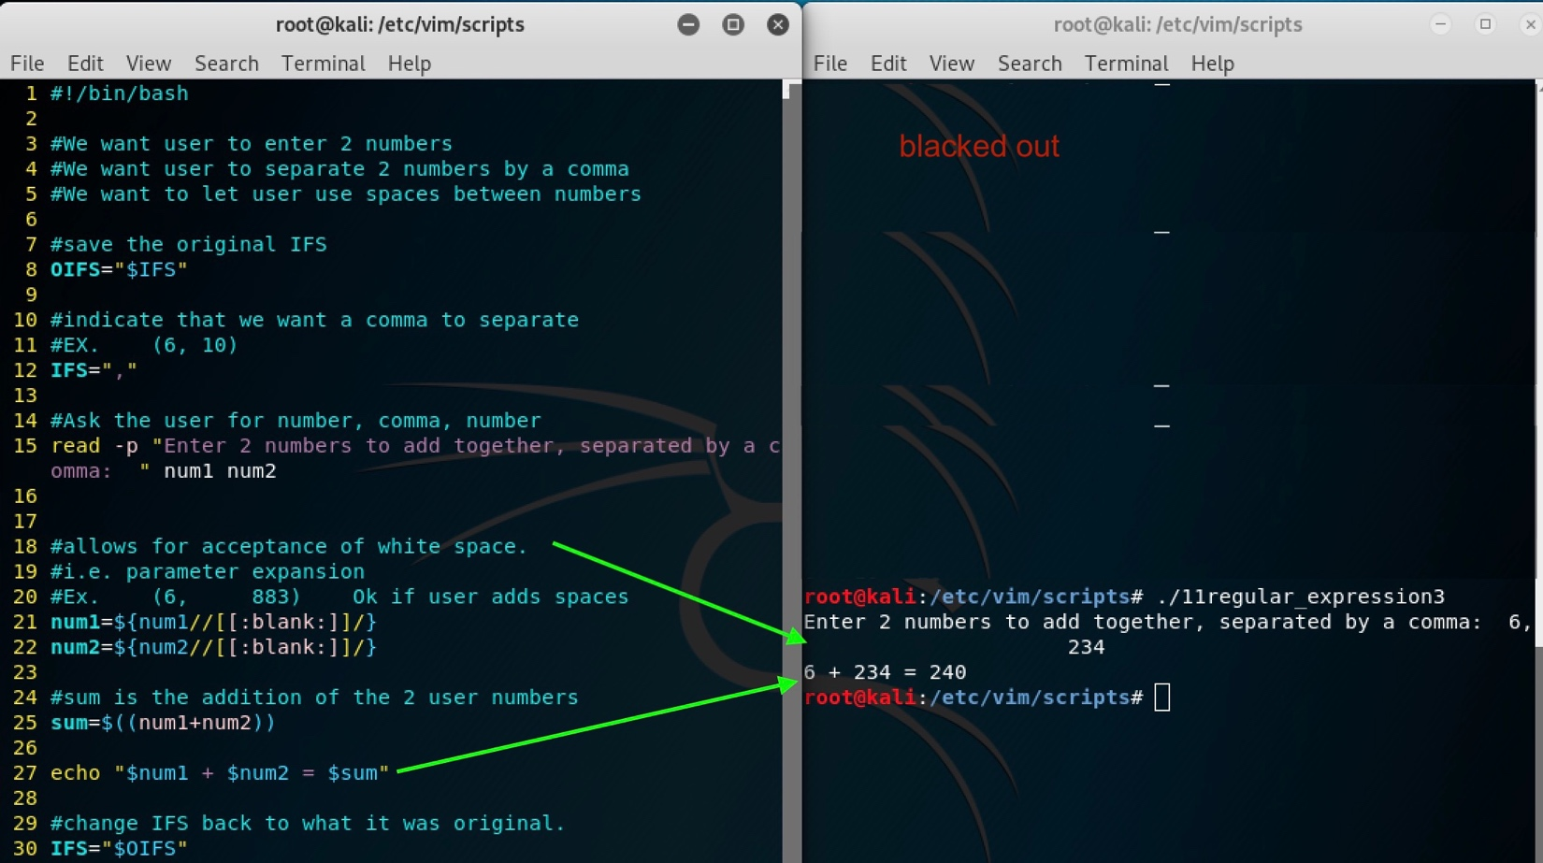

SC – 18:41

# Parameter expansion allows you to do this

name="Derek"

echo "${name}'s Toy"

# The search and replace allows this

samp_string="The dog climbed the tree"

echo "${samp_string//dog/cat}"

sc 18:54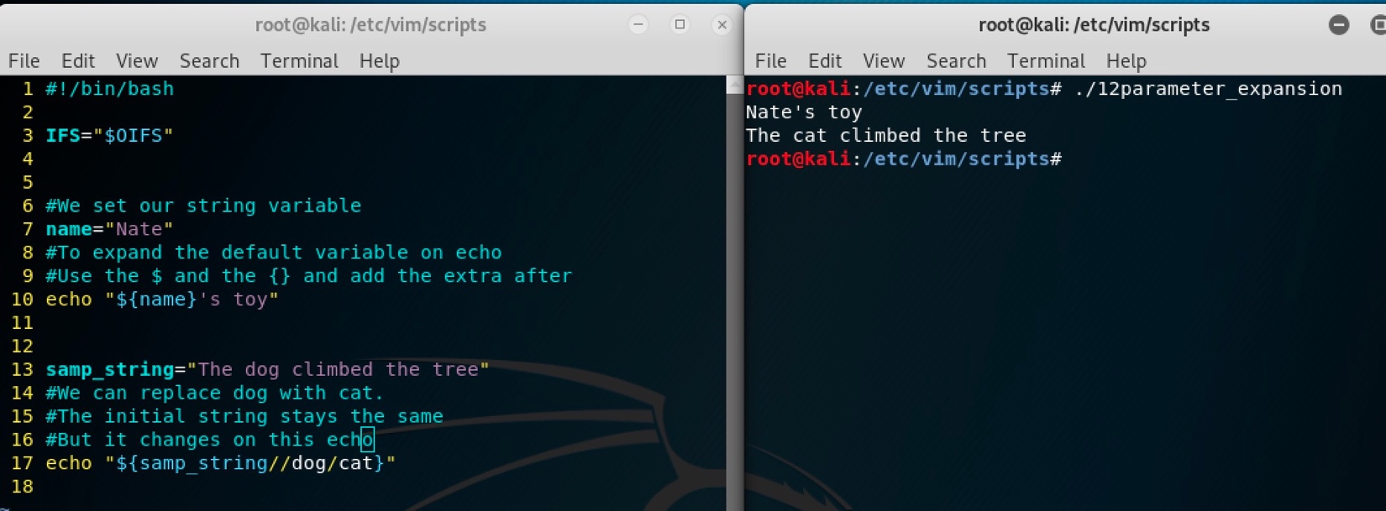

# You can assign a default value if it doesn't exist

echo "I am ${name:-Derek}"

# This uses the default if it doesn't exist and assigns the value

# to the variable

echo "I am ${name:=Derek}"

echo $name

7. Use case to when it makes more sense then if

#!/bin/bash

read -p "How old are you : " age

# Check the value of age

case $age in

# Match numbers 0 - 4

[0-4])

echo "To young for school"

;; # Stop checking further

# Match only 5

5)

echo "Go to kindergarten"

;;

# Check 6 - 18

[6-9]|1[0-8])

grade=$((age-5))

echo "Go to grade $grade"

;;

# Default action

*)

echo "You are to old for school"

;;

esac # End case

8. Ternary Operator performs different actions based on a condition

#!/bin/bash

can_vote=0

age=18

((age>=18?(can_vote=1):(can_vote=0)))

echo "Can Vote : $can_vote"

sc – 21:21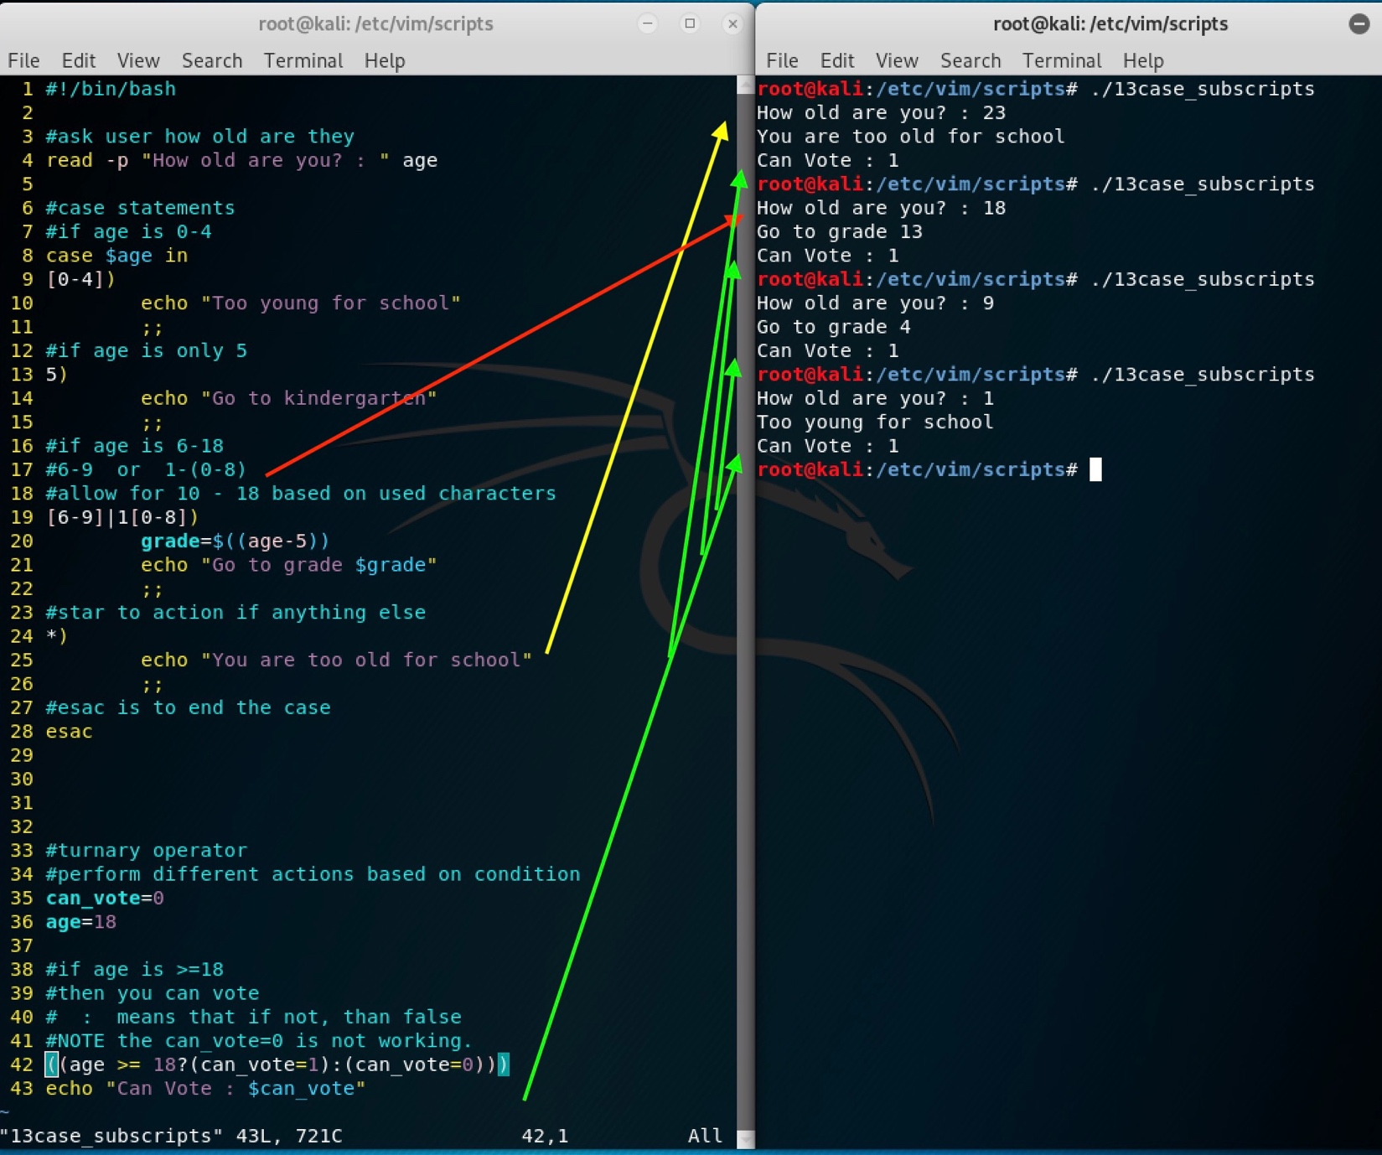

IV. Parameter Expansions and Strings

1. Strings

#!/bin/bash

rand_str="A random string"

# Get string length

echo "String Length : ${#rand_str}"

# Get string slice starting at index (0 index)

echo "${rand_str:2}"

# Get string with starting and ending index

echo "${rand_str:2:7}"

# Return whats left after A

echo "${rand_str#*A }"

sc 21:32

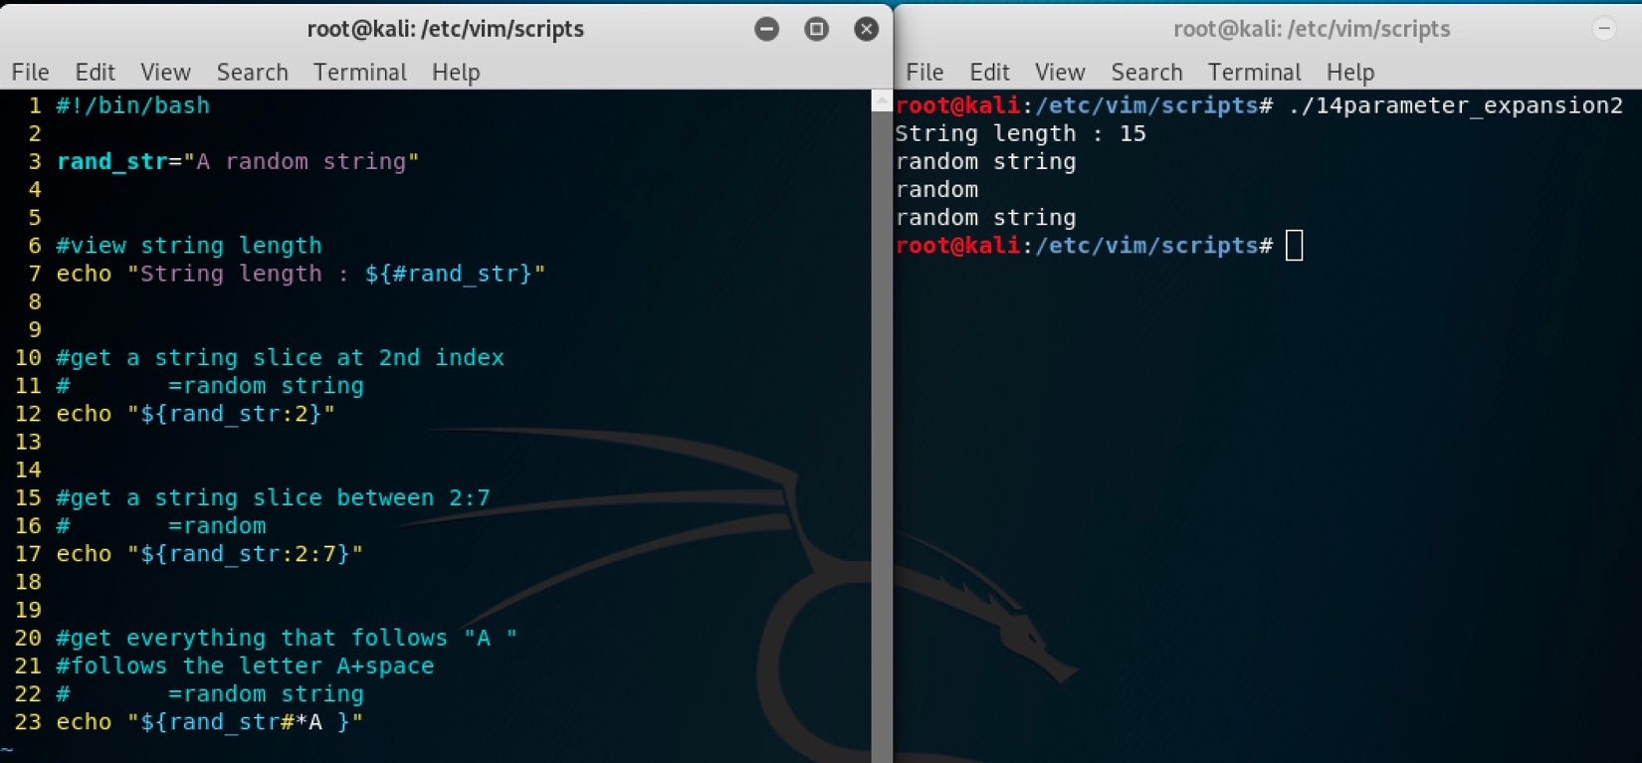

V. Looping

1. While Loop

#!/bin/bash

num=1

while [ $num -le 10 ]; do

echo $num

num=$((num + 1))

done

2. Continue and Break

#!/bin/bash

num=1

while [ $num -le 20 ]; do

# Don't print evens

if (( ((num % 2)) == 0 )); then

num=$((num + 1))

continue

fi

# Jump out of the loop with break

if ((num >= 15)); then

break

fi

echo $num

num=$((num + 1))

done

sc – 21:45

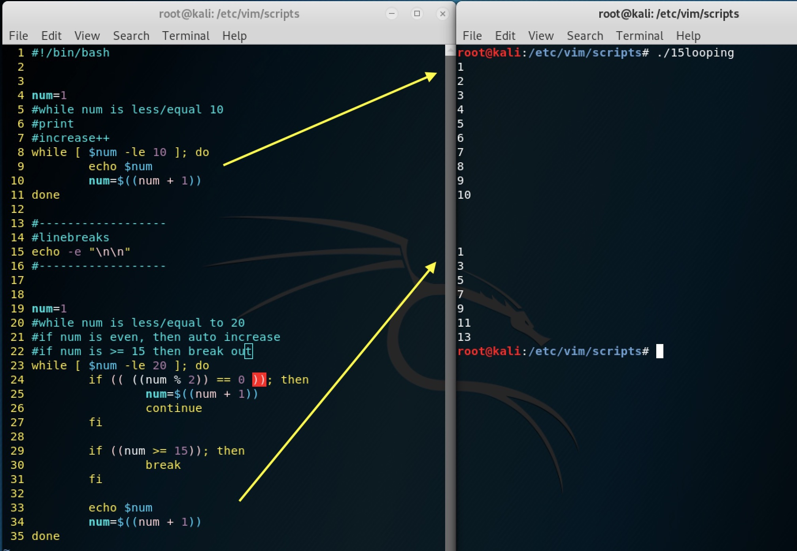

3. Until loops until the loop is true

#!/bin/bash

num=1

until [ $num -gt 10 ]; do

echo $num

num=$((num + 1))

done

sc -2149

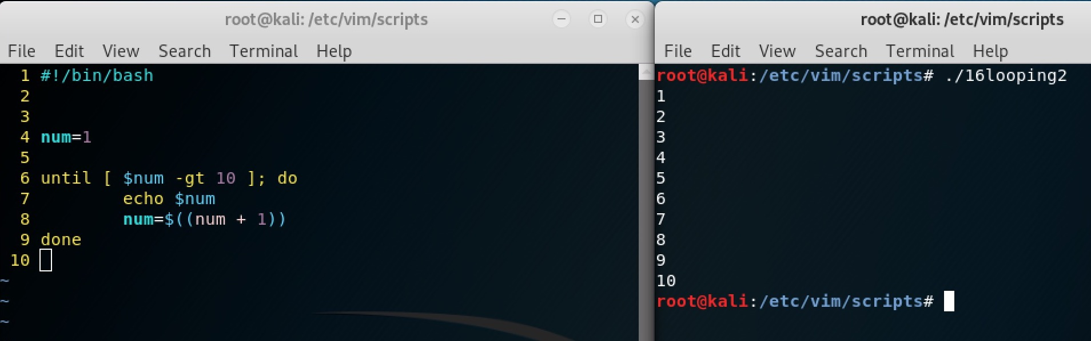

4. Use read and a loop to output file info

#!/bin/bash

while read avg rbis hrs; do

# printf allows you to use \n

printf "Avg: ${avg}\nRBIs: ${rbis}\nHRs: ${hrs}\n"

# Pipe data into the while loop

done < barry_bonds.txt

sc 00:06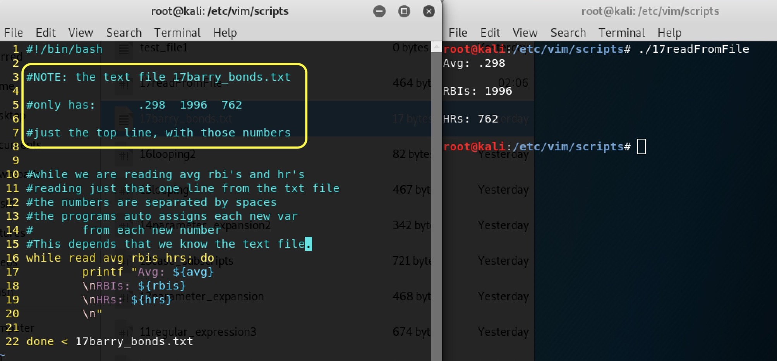

5. There are many for loop options. Here is the C form.

#!/bin/bash

for (( i=0; i <= 10; i=i+1 )); do

echo $i

done

6. We can cycle through ranges

#!/bin/bash

for i in {A..Z}; do

echo $i

done

sc – 00:09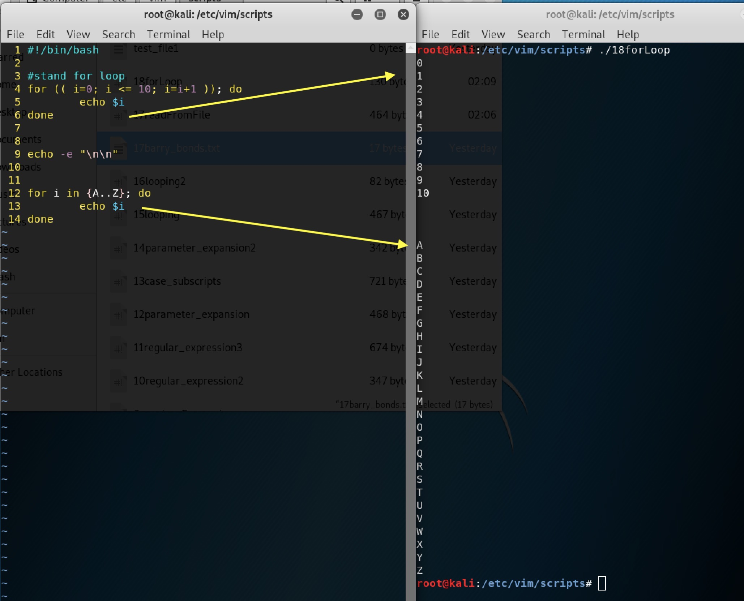

7.

VI. Arrays

1. Bash arrays can only have one dimension and indexes start at 0

2. Messing with arrays

#!/bin/bash

# Create an array

fav_nums=(3.14 2.718 .57721 4.6692)

echo "Pi : ${fav_nums[0]}"

# Add value to array

fav_nums[4]=1.618

echo "GR : ${fav_nums[4]}"

# Add group of values to array

fav_nums+=(1 7)

# Output all array values

for i in ${fav_nums[*]}; do

echo $i;

done

sc – 00:16

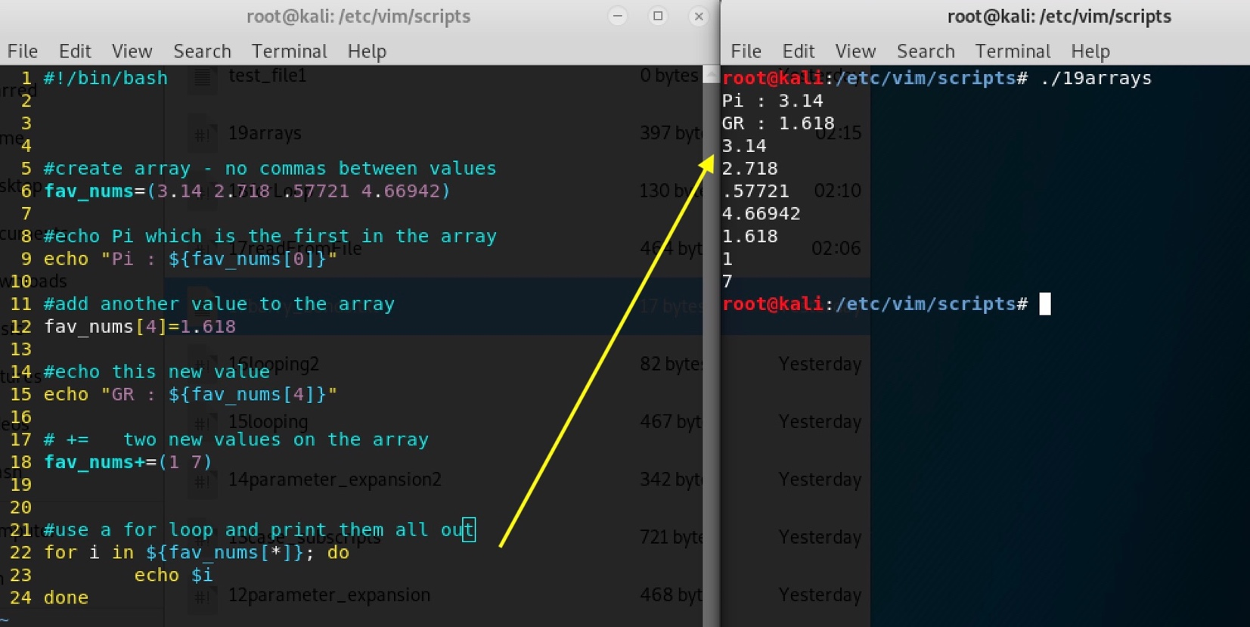

# Output indexes

for i in ${!fav_nums[@]}; do

echo $i;

done

# Get number of items in array

echo "Array Length : ${#fav_nums[@]}"

# Get length of array element

echo "Index 3 length : ${#fav_nums[3]}"

# Sort an array

sorted_nums=($(for i in "${fav_nums[@]}"; do

echo $i;

done | sort))

for i in ${sorted_nums[*]}; do

echo $i;

done

# Delete array element

unset 'sorted_nums[1]'

# Delete Array

unset sorted_nums

sc 8:58am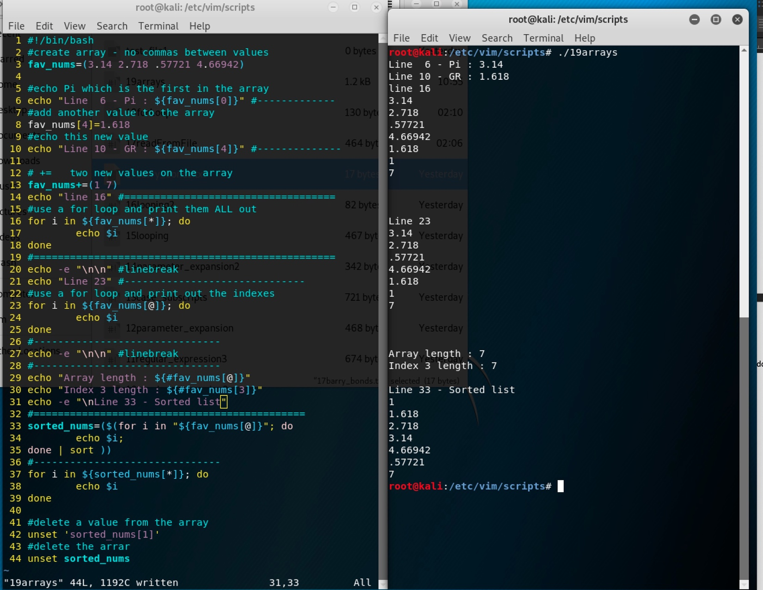

VII. Positional Parameters

1. Positional parameters are variables that can store data on the command line in variable names 0 - 9

a. $0 always contains the path to the executed script

b. You can access names past 9 by using parameter expansion like this ${10}

2. Add all numbers on the command line

#!/bin/bash

# Print the first argument

echo "1st Argument : $1"

sum=0

# $# tells you the number of arguments

while [[ $# -gt 0 ]]; do

# Get the first argument

num=$1

sum=$((sum + num))

# shift moves the value of $2 into $1 until none are left

# The value of $# decrements as well

shift

done

echo "Sum : $sum"

🡪 The function takes in the 5 numbers with the execution of the program

And adds them up.

